# Design

## Software Design

### Flowchart

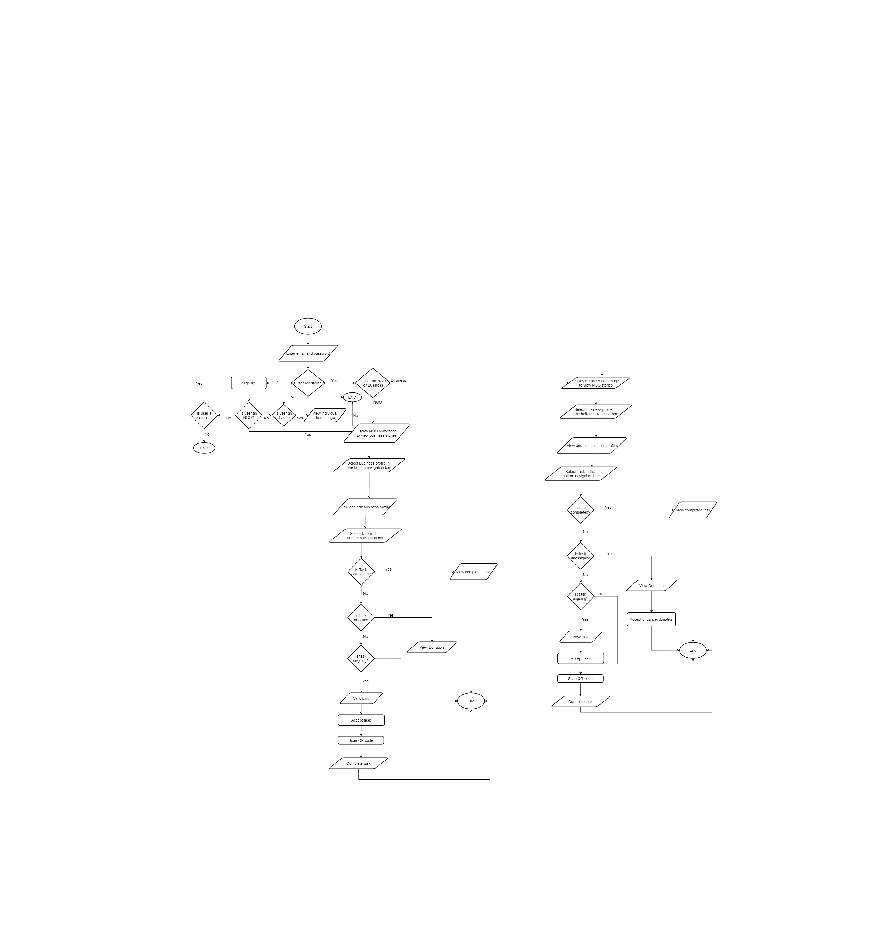

## UI Design

### Login Page

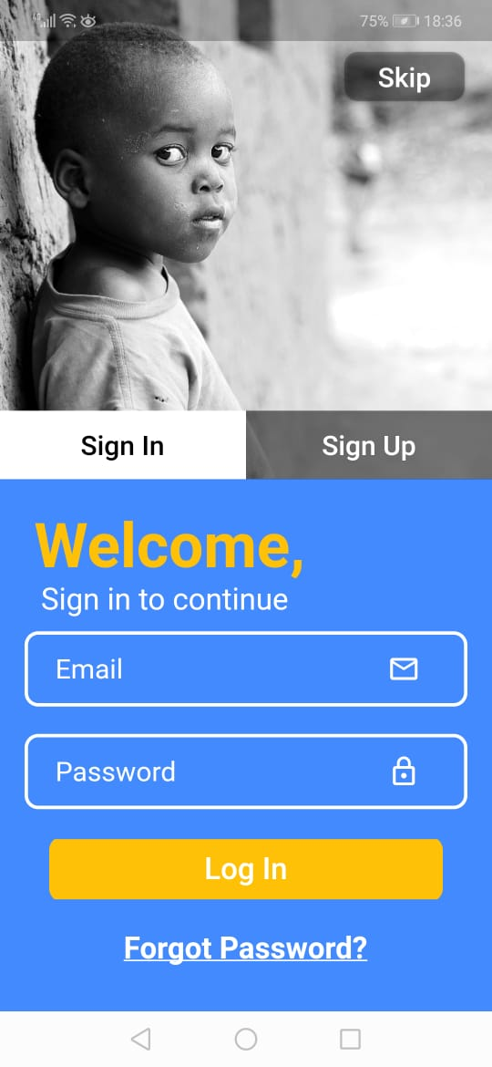

### Sign Up Page

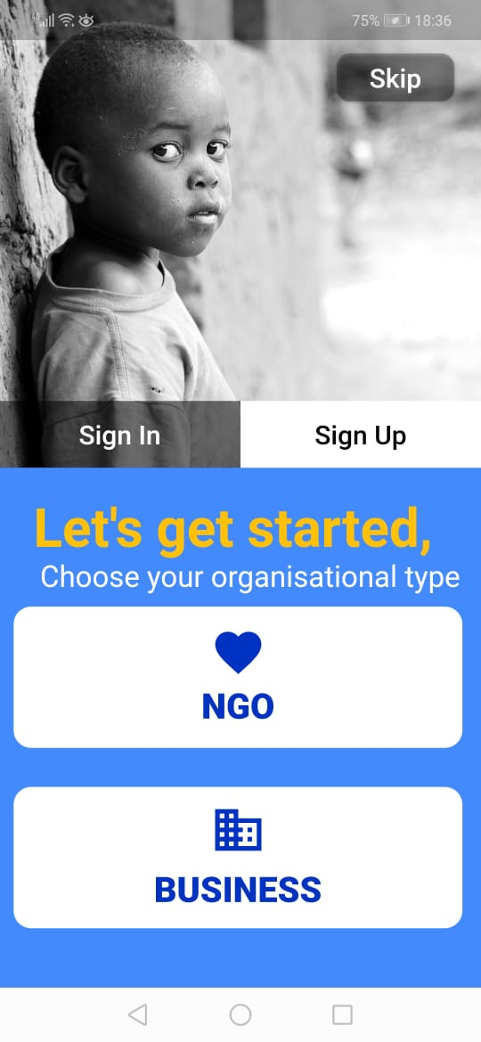

### NGO and Business Setting Page

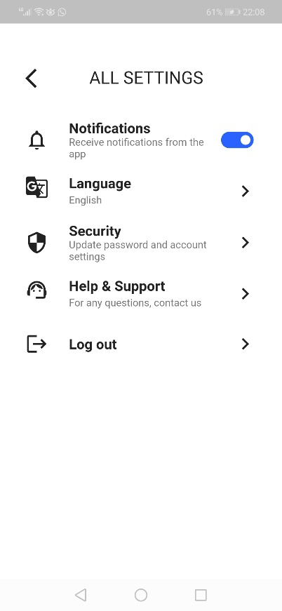

### Individual Setting Page

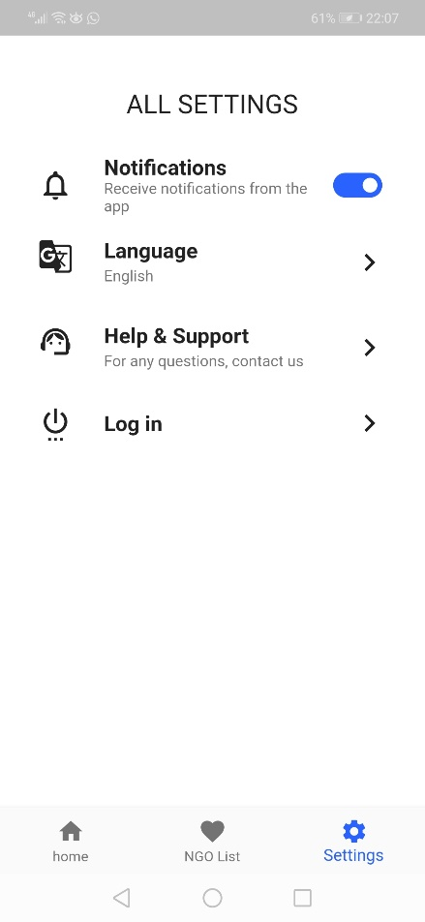

# Implementation

## Login Page Background

Positioned(  
 top: 0,  
 left: 0,  
 child: Image.asset(  
 "assets/JPEG/image.jpg",  
 width: size.width * 1.0,  
),  
),

## Sign Up Page NGO and Business Button

SocalIcon(  
 iconSrc: "assets/SVG/NGO Button.svg",  
  
 press: () {  
 Navigator.*push*(  
 context,  
 MaterialPageRoute(  
 builder: (context) {  
 return NGO();  
 },  
 ),  
 );  
 },  
 ),  
 SocalIcon(  
  
 iconSrc: "assets/SVG/Business Button.svg",  
 press: () {  
 Navigator.*push*(  
 context,  
 MaterialPageRoute(  
 builder: (context) {  
 return Business();  
 },  
 ),  
 );  
 },  
 ),

## List Tiles for one setting in NGO

ListTile(  
 leading: Icon(  
 Icons.*notifications_none_outlined*,  
 color: Colors.*black87*,  
 size: 30.0,  
 ),  
 title: Text("Notifications" ,  
 style: TextStyle(  
 fontFamily: "risotto",  
 fontSize: 18.0,  
 fontWeight: FontWeight.*bold*,  
 ),  
),  
  
 subtitle: Text('Receive notifications from the app',  
 style: TextStyle(  
 fontFamily: "risotto",  
 fontSize: 13.0,  
  
 ),  
 ),  
 trailing: Icon(Icons.*toggle_on*,color: Colors.*blueAccent*[700],size: 50.0,),  
 onTap: () {

},  
),